**Probability Terms**

1. A planned activity to generate outcome/data is called an **experiment**.
2. A single performance of an experiment is called a **trial**.
3. An experiment which can be repeated several times under similar conditions providing different results is called a **random experiment**.
4. A **probability experiment** is a chance process that leads to well-defined results called outcomes.
5. An **outcome** is the result of a single trial of a probability experiment.

* For example, if a die is rolled and a 6 shows, this result is called an outcome, since it is a result of a single trial.

1. Possible outcomes/elements are called **sample points**.
2. A **sample space** is the set of all possible outcomes from an experiment.
3. An **event** consists of a set of all favourable outcomes from sample space/experiment. It is a subset of sample space.
4. An event with one outcome is called a **simple event**.
5. An event with more than one outcome is called a **compound event**.
6. An event with outcomes not from the sample space is called an **impossible event**.
7. **Equally likely** events are events that have the same probability of occurring.
8. If the union of all events equals the sample space, then the set of events is called **exhaustive events**.

* When tossing a coin, the union of events "heads" and "tails" is a set of exhaustive events because it includes all possible outcomes.

1. Two or more events are **mutually exclusive** (or disjoint) if they cannot occur at the same time.

* P(A∩B)=0
* P(A∪B∪C)=P(A)+P(B)+P(C) **Addition Law (1)**

1. Two events are **not mutually exclusive** if they can occur at the same time.

* P(A∩B)!=0
* P(A∪B)=P(A)+P(B)-P(A∩B) **Addition Law (2)**

1. Two events are **independent** if the occurrence of one does not affect the probability of the other.

* P(A∩B)=P(A)×P(B) **Multiplication Law (1)**

1. Two events are **dependent** if the occurrence of one affects the probability of the other.

* P(A∩B)=P(A)×P(B∣A) **Multiplication Law (2)**
* P(A∩B)=P(B)×P(A∣B) **Multiplication Law (2)**

1. The total possible outcomes in a scenario can be known by the formula:

* (Total number of outcomes in a single trial) ^ (Total number of trials)
* When rolling 2 dice together, total outcomes in a single die are 6 and is rolled 2 times so, 6^2 = 36 total outcomes.

There are three basic interpretations of probability:

**1. Classical probability**

**2. Empirical or relative frequency probability** (Not included in Course)

**3. Subjective probability** (Not included in Course)

**Classical Probability**

Classical probability uses sample spaces to determine the numerical probability that an event will happen. You do not actually have to perform the experiment to determine that probability.

*Classical probability assumes that all outcomes in the sample space are* ***equally likely*** *to occur.* For example, when a single die is rolled, each outcome has the same probability of occurring. Since there are six outcomes, each outcome has a probability of 1/6.

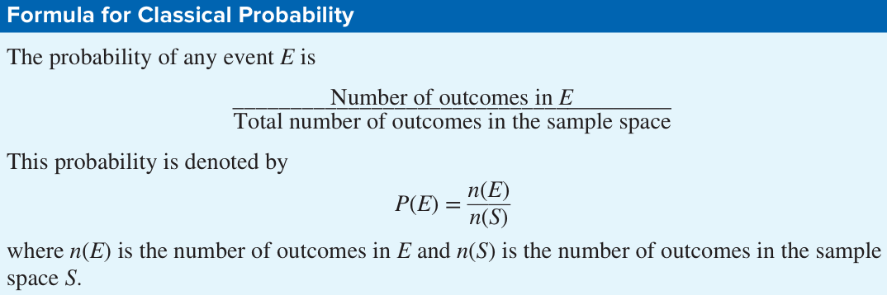

In probability theory, it is important to understand the meaning of the words **and** & **or**.

* "**And**" signifies that both events must occur simultaneously.
* It represents the intersection of events.
* Mathematically, "A and B" is denoted as A∩B.
* "**Or**" signifies that at least one of the events must occur.
* It represents the union of events.
* Mathematically, "A or B" is denoted as A∪B.

1. The word **and** means “at the same time.”

For example, if you were asked to find the probability of getting a queen **and** a heart when you were drawing a single card from a deck, you would be looking for the **queen of hearts** (one card only: 1/52).

2. The word **or** has two meanings.

For example, if you were asked to find the probability of selecting a queen **or** a heart (**Not Mutually Exclusive**) when one card is selected from a deck, you would be looking for one of the 4 queens or one of the 13 hearts. In this case, the queen of hearts would be included in both cases and counted twice.

P(A∪B)=P(A)+P(B)−P(A∩B)

So, there would be 4 + 13 − 1 = 16 possibilities. Therefore, the probability is 16/52.

On the other hand, if you were asked to find the probability of getting a queen **or** a king (**Mutually Exclusive**), you would be looking for one of the 4 queens or one of the 4 kings.

In this case, P(A∩B)=0 so P(A∪B)=P(A)+P(B)

So, there would be 4 + 4 = 8 possibilities. Therefore the probability is 8/52.

In the first case, both events can occur at the same time; we say that this is an example of the **inclusive or**. In the second case, both events cannot occur at the same time, and we say that this is an example of the **exclusive or**.

**Range of Probability**

**Sum Of The Probabilities Of All The Outcomes In A Sample Space**

1. The sample space is the set all possible outcomes of the coin toss. **S.S = {heads, tails}**

2. The possible outcomes are **heads or tails**.

3. Classical probability says that both the outcomes are equally likely, meaning a fair coin has a 50% chance of coming up heads and a 50% chance of coming up tails.

**2 Dice are Rolled**

**Sum of 2:** (1, 1)

**Sum of 3:** (1, 2), (2, 1)

**Sum of 4:** (1, 3), (3, 1), (2, 2)

**Sum of 5:** (1, 4), (4, 1), (2, 3), (3, 2)

**Sum of 6:** (1, 5), (5, 1), (2, 4), (4, 2), (3, 3)

**Sum of 7:** (1, 6), (6, 1), (2, 5), (5, 2), (3, 4), (4, 3)

**Sum of 8:** (2,6), (6,2), (3,5), (5,3), (4,4)

**Sum of 9:** (3,6), (6,3), (4,5), (5,4)

**Sum of 10:** (4, 6), (6, 4), (5, 5)

**Sum of 11:** (5, 6), (6, 5)

**Sum of 12:** (6, 6)

**If two dice are rolled one time, find the probability of getting these results:**

**a. A sum of 5**

* The probability is 4/36, which simplifies to 1/9.

**b. A sum of 9 or 10**

* The probability is 7/36.

**c. Doubles**

(1, 1), (2, 2), (3, 3), (4, 4), (5, 5), (6, 6)

* The probability is 6/36, which simplifies to 1/6.

**Drawing a Card If a card is drawn from a deck, find the probability of getting these results:**

**a. A 6 and a spade**

* The card that is both a 6 and a spade.
* Probability = 1/52.

**b. A black king**

* Probability = 2/52 = 1/26.

**c. A red card and a 7**

* A card that is both red and a 7. The 7 of hearts and the 7 of diamonds.
* Probability = 2/52 = 1/26.

**d. A diamond or a heart**

* Since these are mutually exclusive events (a card cannot be both a diamond and a heart), we add the probabilities.
* Probability = (13/52) + (13/52) = 26/52 = 1/2.

**e. A black card**

* Probability = 26/52 = 1/2.

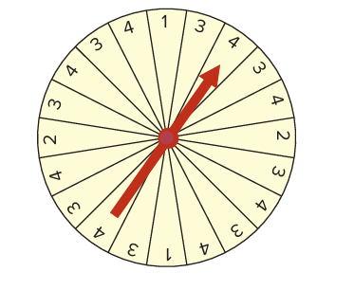

**Shopping Mall Promotion**: A shopping mall has set up a promotion as follows. With any mall purchase of $50 or more, the customer gets to spin the wheel shown here. If a number 1 comes up, the customer wins $10. If the number 2 comes up, the customer wins $5; and if the number 3 or 4 comes up, the customer wins a discount coupon. Find the following probabilities.

First, we need to count the total number of sections on the wheel. There are 20 sections.

N**umber of Each Outcome:**

* **1:** There are 2 sections with the number 1.
* **2:** There are 2 sections with the number 2.
* **3:** There are 8 sections with the number 3.
* **4:** There are 8 sections with the number 4.

**a. The customer wins $10.**

* Probability = 2/20 = 1/10

**b. The customer wins money.**

* Probability = 4/20 = 1/5

**c. The customer wins a coupon.**

* Probability = 16/20 = 4/5

**Human Blood Types**: Human blood is grouped into four types. The percentages of each type are listed below.

O 43% A 40% B 12% AB 5%

Choose one person at random. Find the probability that this person

**a. Has type B blood**

* The percentage of Americans with type B blood is 12%.
* Probability (Type B) = 0.12

**b. Has type AB or O blood**

* Probability (Type AB) = 5% = 0.05
* Probability (Type O) = 43% = 0.43
* Since these are mutually exclusive events (a person cannot have both AB and O blood), we add the probabilities:
* Probability (Type AB or O) = 0.05 + 0.43 = 0.48

**c. Does not have type O blood**

**Method 1:** Add the probabilities of the other blood types (A, B, and AB).

* Probability (Type A) = 40% = 0.40
* Probability (Type B) = 12% = 0.12
* Probability (Type AB) = 5% = 0.05
* Probability (Not Type O) = 0.40 + 0.12 + 0.05 = 0.57

**Method 2:** Subtract the probability of having type O blood from 1 (since the total probability must be 1).

* Probability (Type O) = 43% = 0.43
* Probability (Not Type O) = 1 - 0.43 = 0.57

**Sources of Energy Uses in the United States**: A break down of the sources of energy used in the United States is shown below. Choose one energy source at random. Find the probability that it is

Oil (39%) Natural gas (24%) Coal (23%) Nuclear (8%) Hydropower (3%) Other (3%)

**a. Not oil**

* Probability (Not oil) = 1 - 0.39 = 0.61

**b. Natural gas or oil**

* The probability of natural gas is 24% or 0.24.
* The probability of oil is 39% or 0.39.
* Since these are mutually exclusive events (an energy source cannot be both natural gas and oil), we add the probabilities.
* Probability (Natural gas or oil) = 0.24 + 0.39 = 0.63

**c. Nuclear**

* The probability of nuclear energy is 8% or 0.08.
* Probability (Nuclear) = 0.08

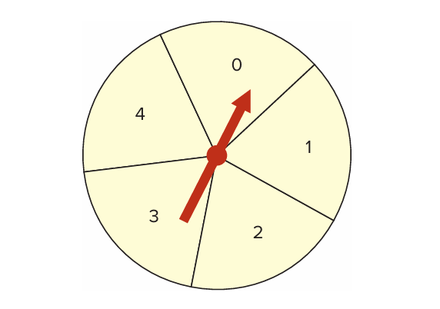**Wheel Spinner**: The wheel spinner shown here is spun twice. Find the sample space and then determine the probability of the following events.

* The spinner has 5 sections: 0, 1, 2, 3, 4.
* The wheel has spun twice (2).
* There are 52 = 25 possible outcomes in the sample space.
* (0, 0), (0, 1), (0, 2), (0, 3), (0, 4)
* (1, 0), (1, 1), (1, 2), (1, 3), (1, 4)
* (2, 0), (2, 1), (2, 2), (2, 3), (2, 4)
* (3, 0), (3, 1), (3, 2), (3, 3), (3, 4)
* (4, 0), (4, 1), (4, 2), (4, 3), (4, 4)

**a. An odd number on the first spin and an even number on the second spin (Note: 0 is considered even.)**

* Odd numbers on the first spin: 1, 3 (2 possibilities)
* Even numbers on the second spin: 0, 2, 4 (3 possibilities)
* Combinations: (1, 0), (1, 2), (1, 4), (3, 0), (3, 2), (3, 4)
* Total combinations: 2 x 3 = 6
* Probability = 6/25

**b. A sum greater than 4**

* Probability = 10/25 = 2/5

**c. Even numbers on both spins**

* Even numbers: 0, 2, 4 (3 possibilities)
* Total combinations: 3 x 3 = 9
* Probability = 9/25

**d. A sum that is odd**

* Probability = 12/25

**e. The same number on both spins**

* Probability = 5/25 = 1/5